Deploying wordpress web application using docker in amazon web services

Module:1 now creating and launching in amazon linux ec2 instance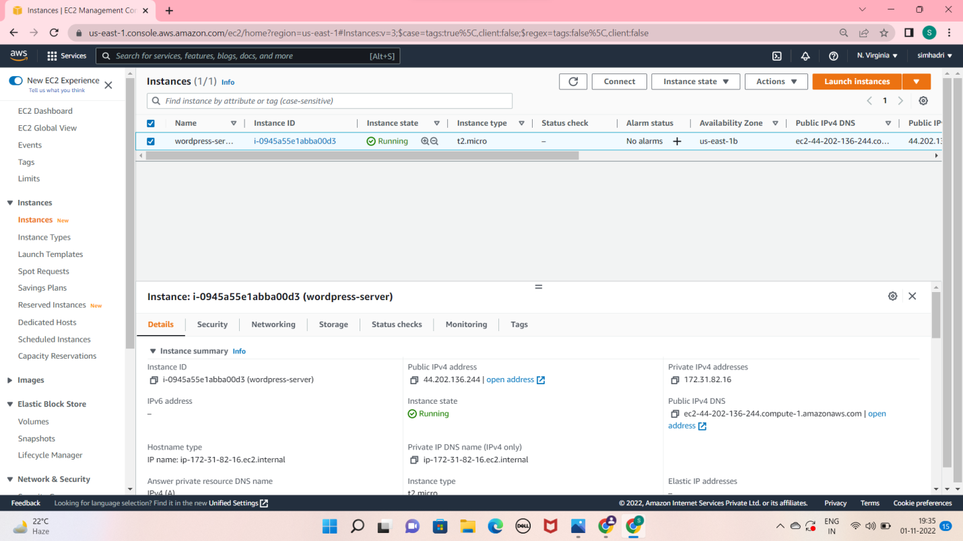

Now connect to the ec2 instance in terminal or any other, with ssh client.

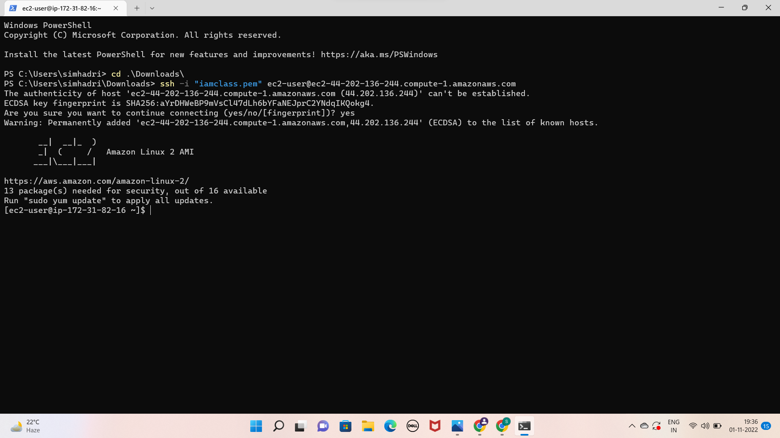

Module:2 install git and docker

Installed my git

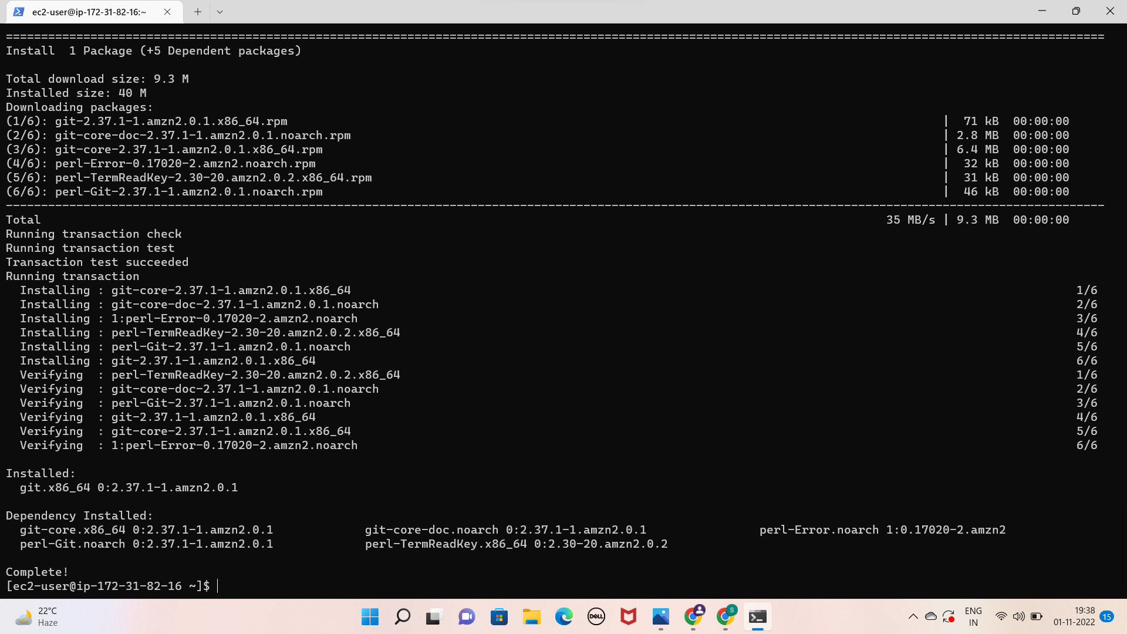

Installed my docker

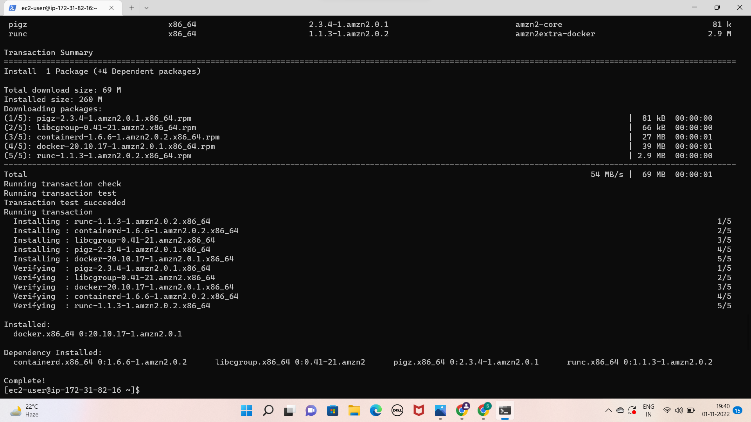

Give the permission

Sudo usermod –a –G docker ec2-user

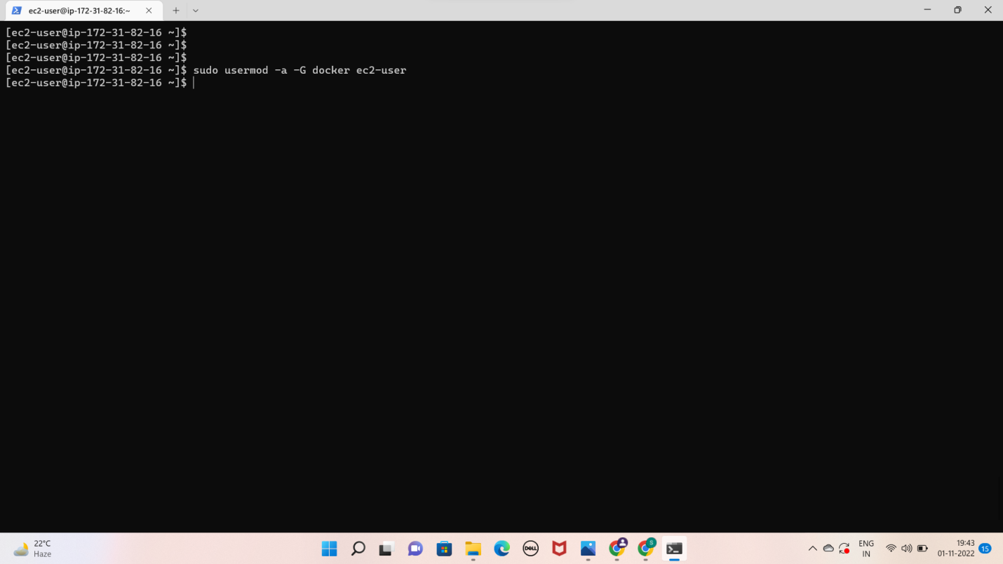

* Start docker service by using below command

Sudo service docker start

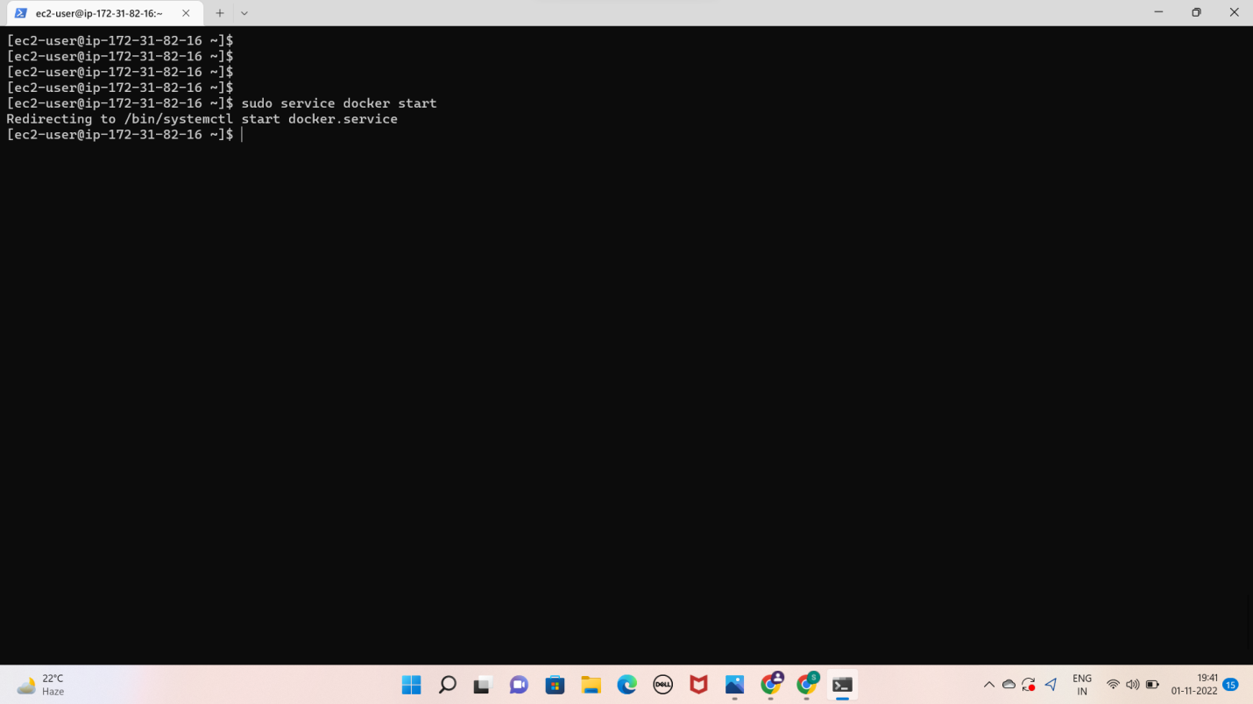

* Run below command to get docker service up automatically after reboot

Sudo chkconfig docker on

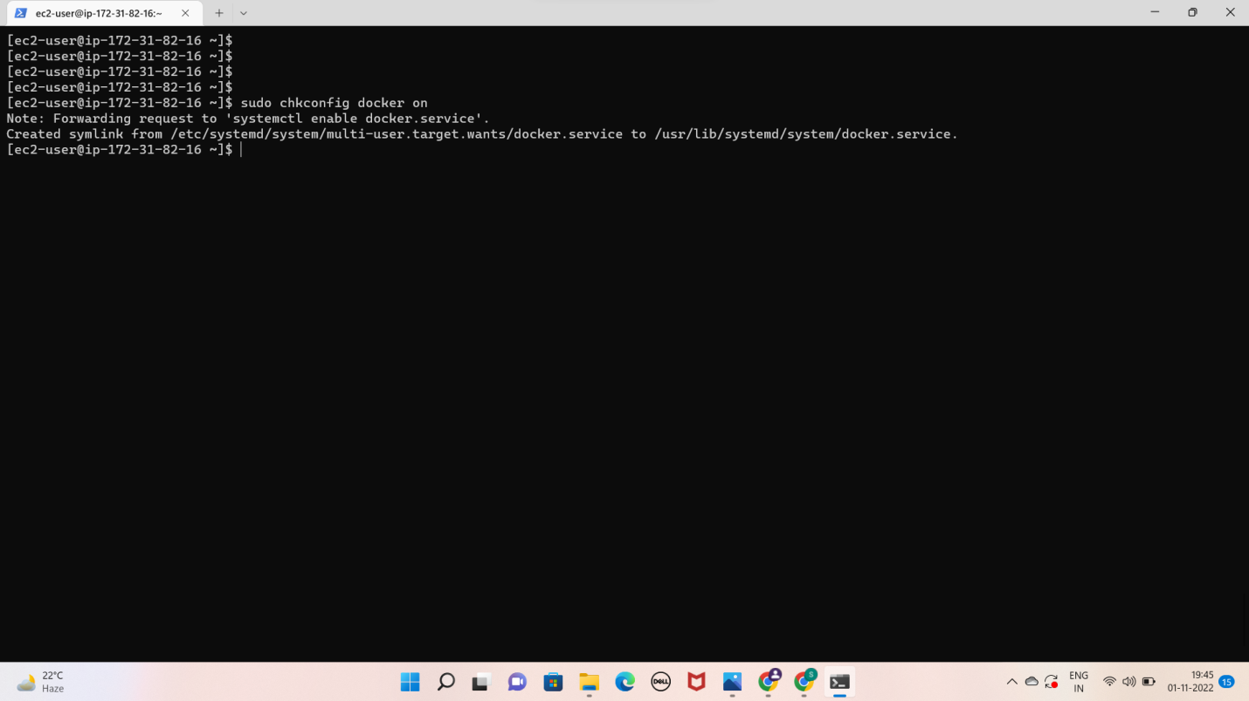

* Install docker compose

Download the latest version of docker compose

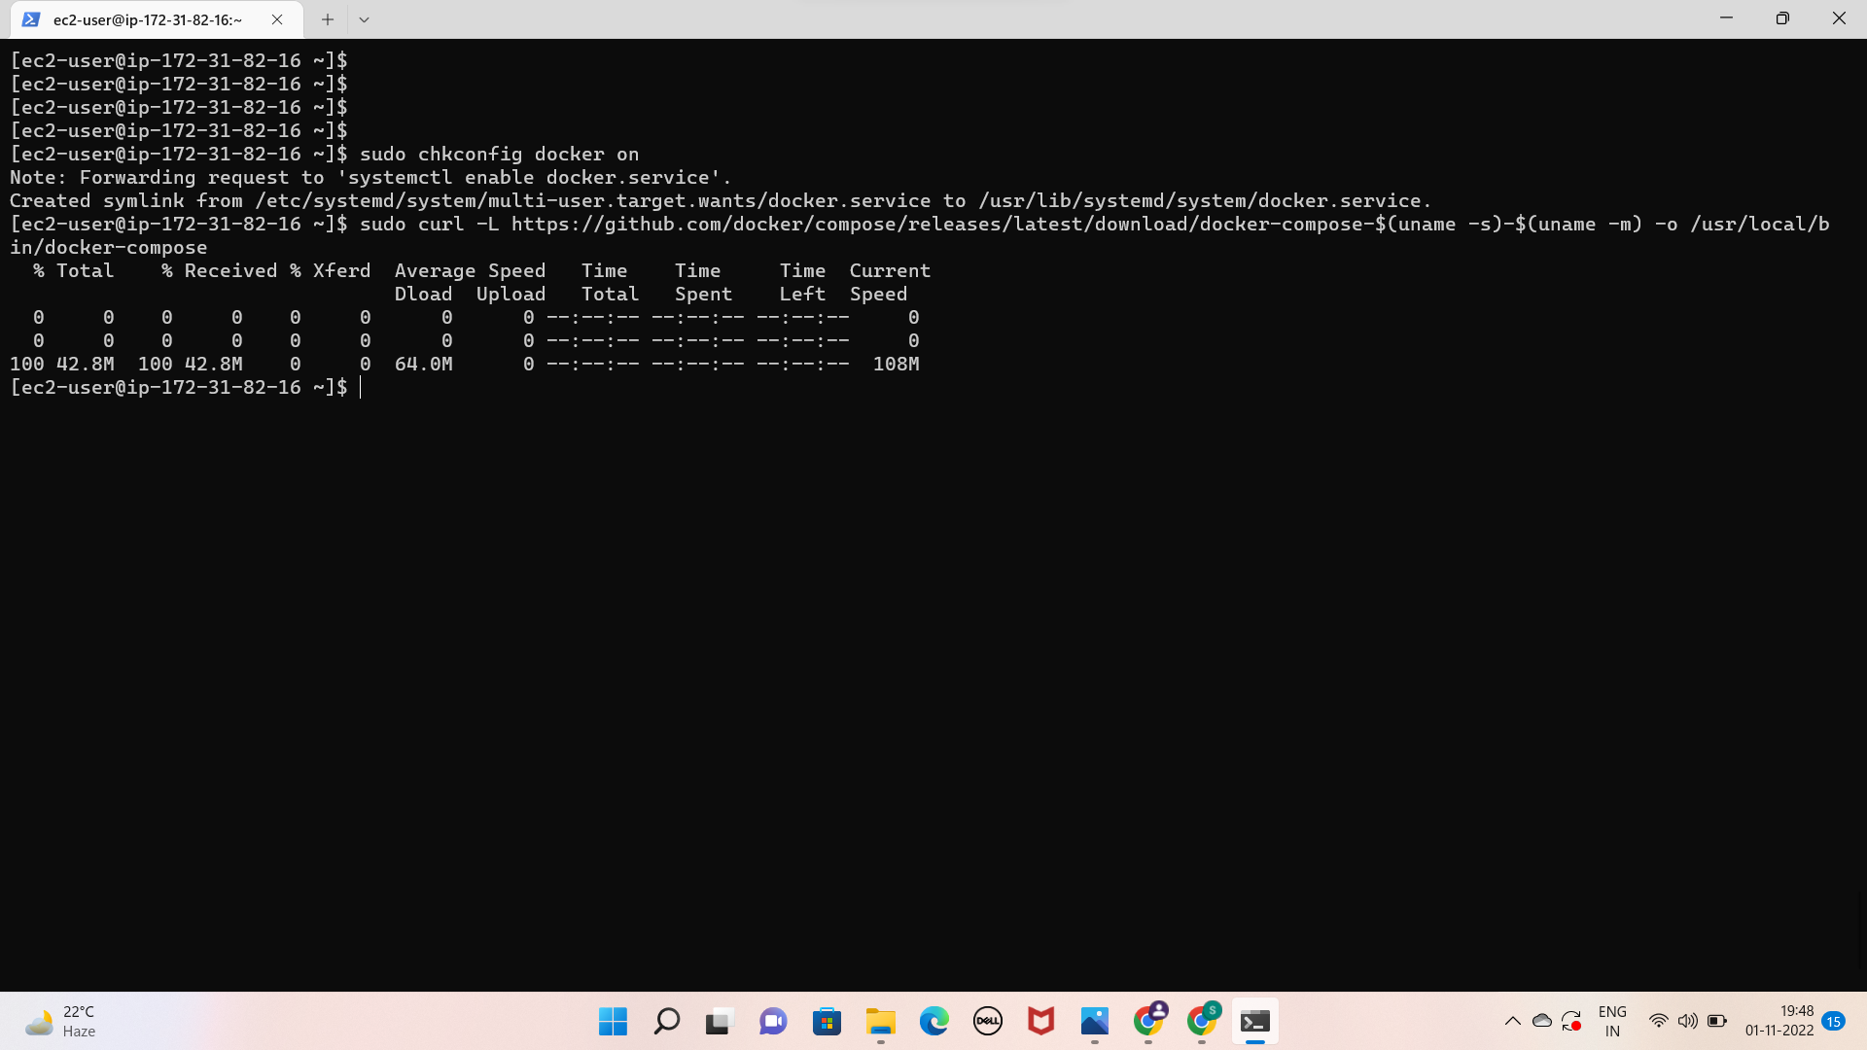

* Apply executable permissions to the binary :

Sudo chmod +x /usr/local/bin/docker-compose

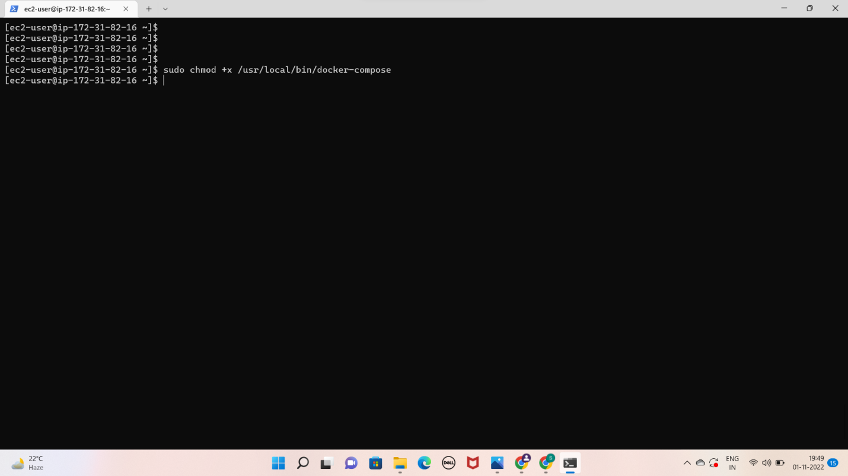

* Create a symbolic link

Ln –s /usr/local/bin/docker-compose /usr/bin/docker-compose

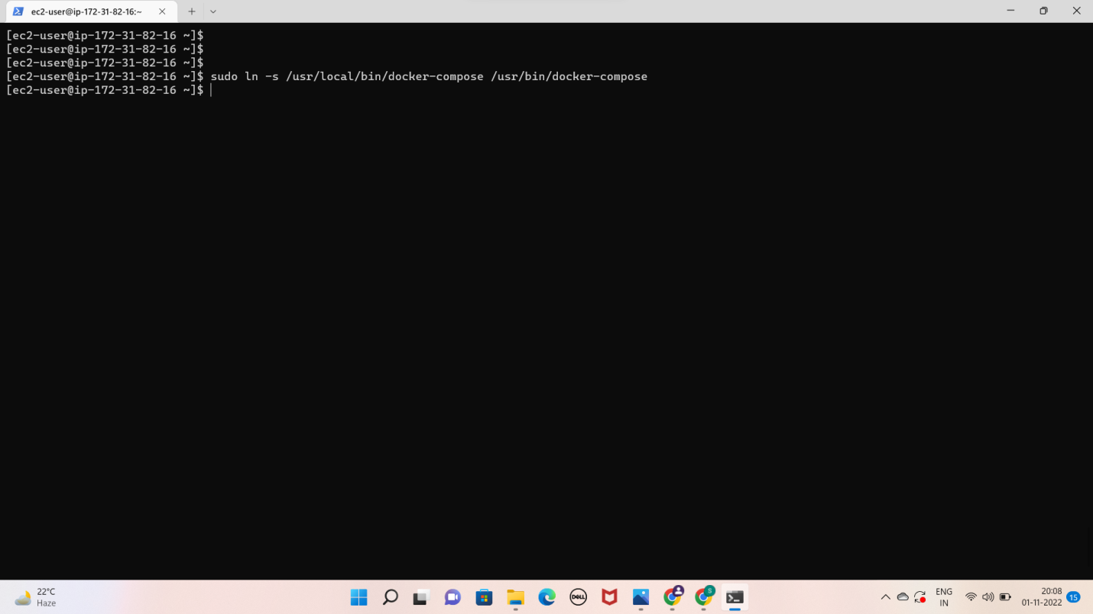

* Check installed docker-compose version

Docker-compose –version

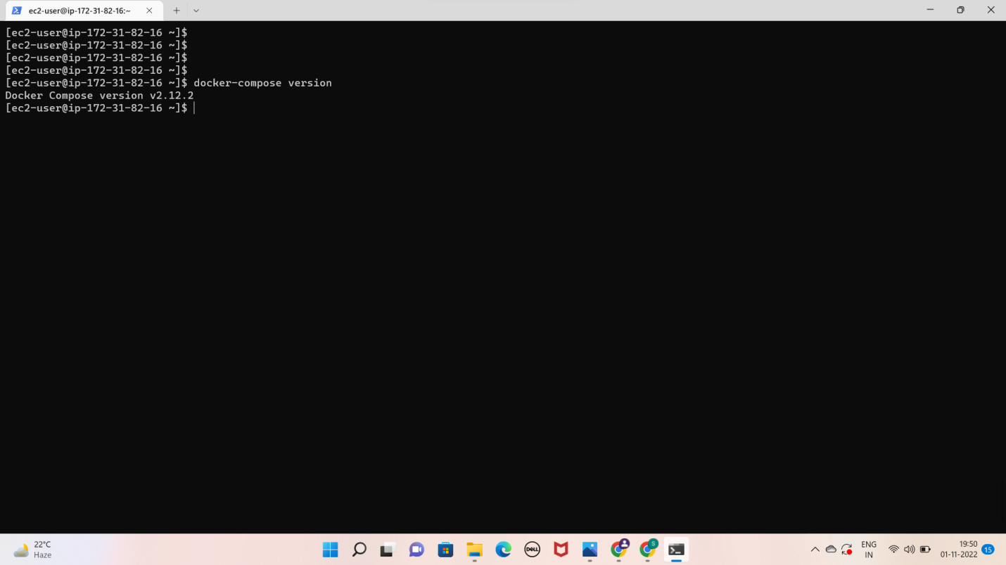

Module:3 - creating wordpress setup for docker images with help of yaml scripting

* Sudo vi docker-compose.yaml
* 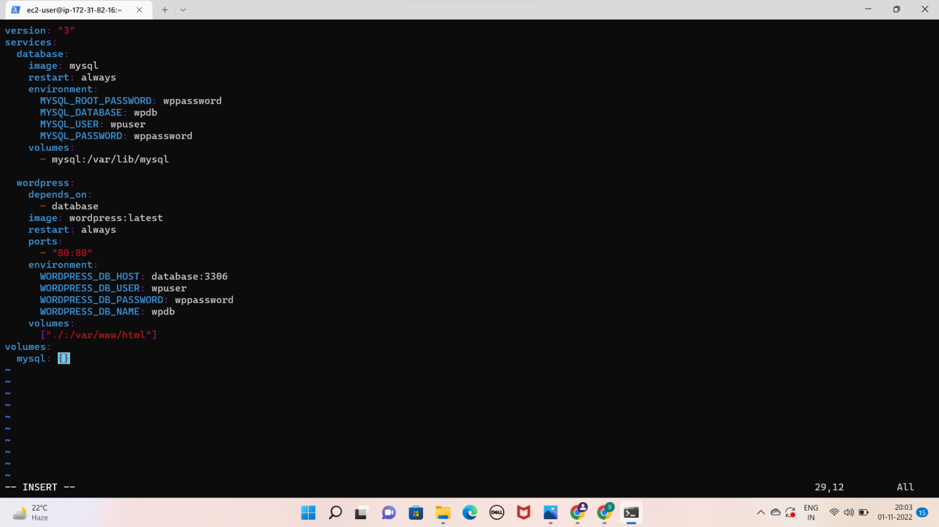

Sudo docker-compose up –d

By using docker-composing.yaml file it was pulling images are mysql and wordpress.

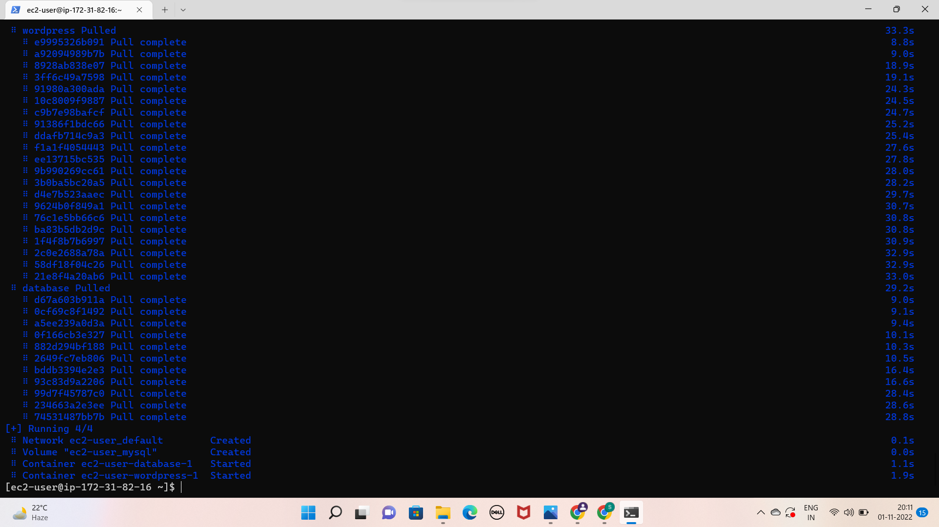

* Sudo docker ps

Then i can get the list of running containers by using above command

* Browse it

Then lastly i had a look to see that this was running correctly

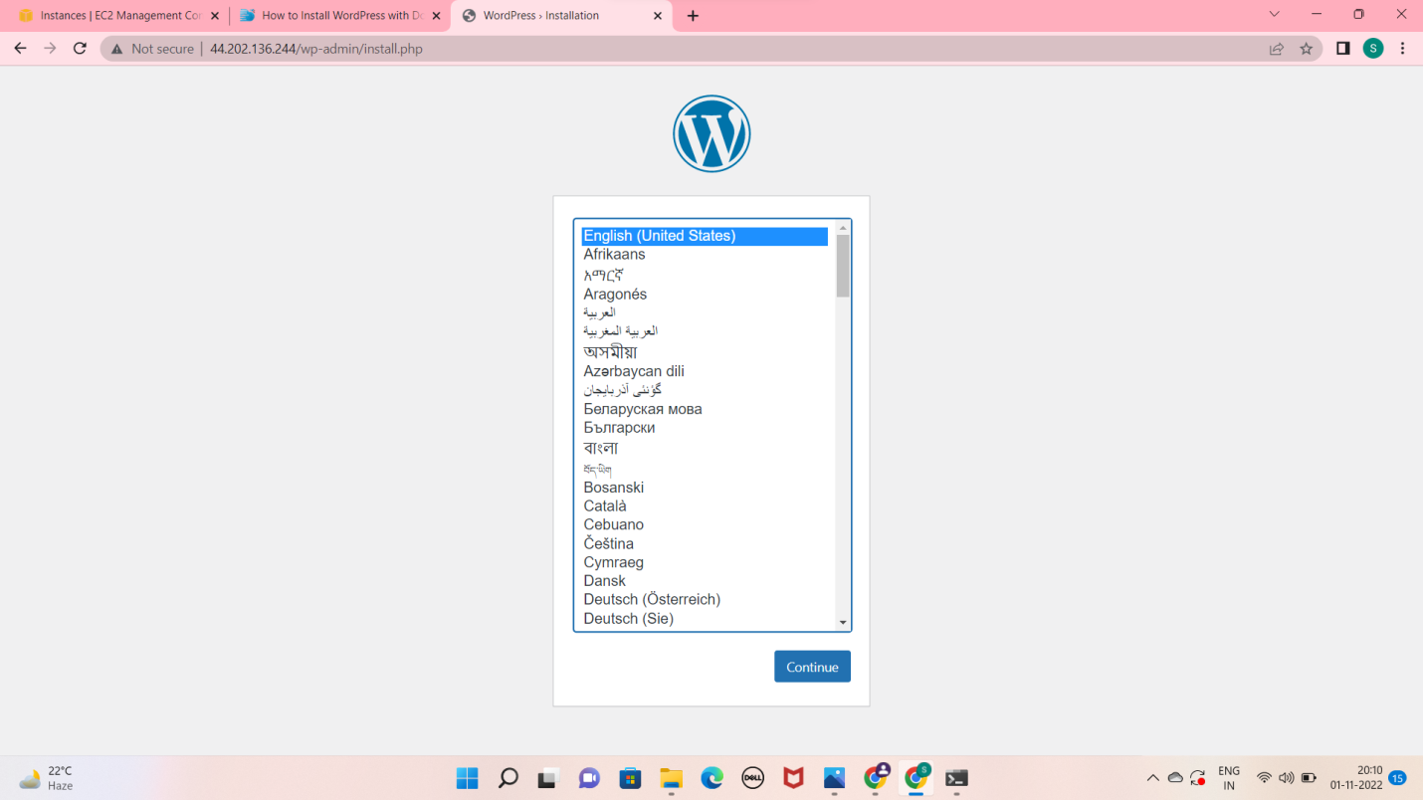

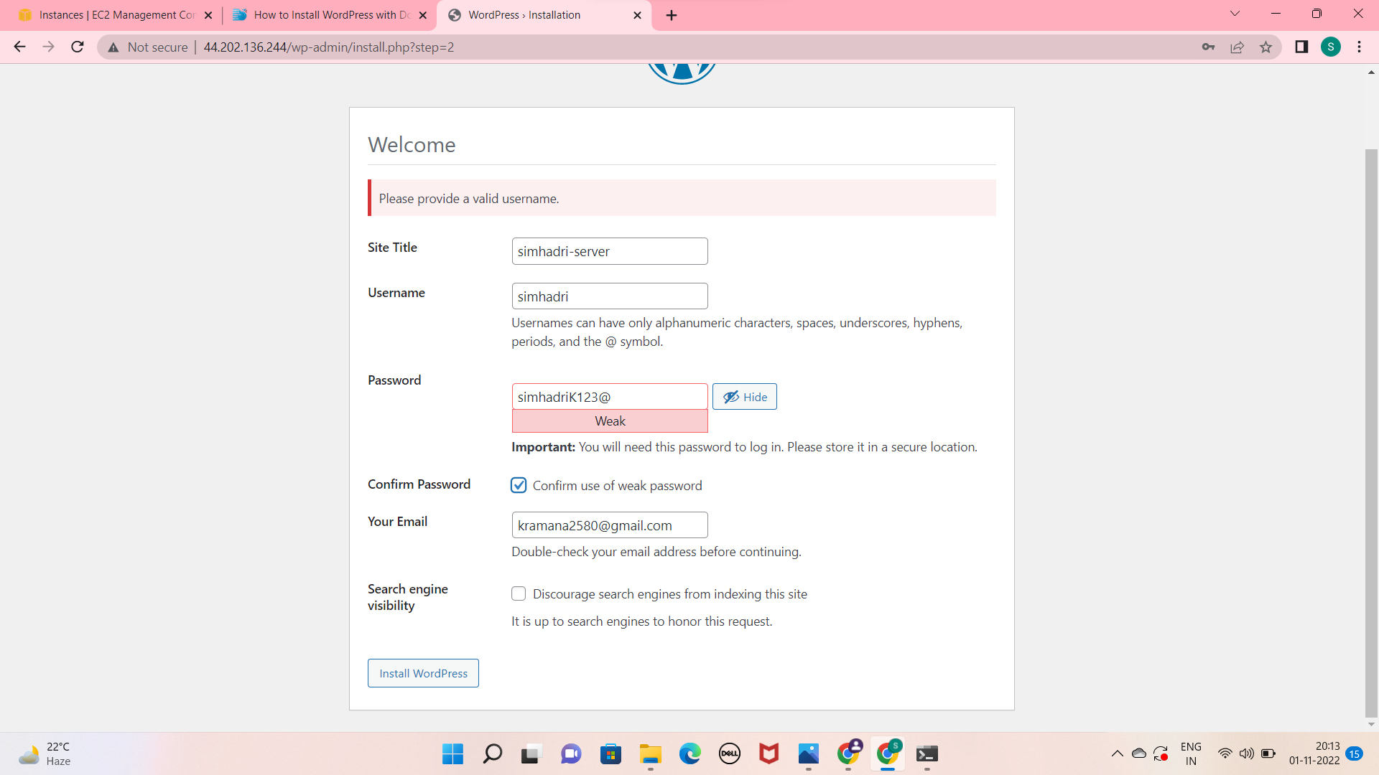

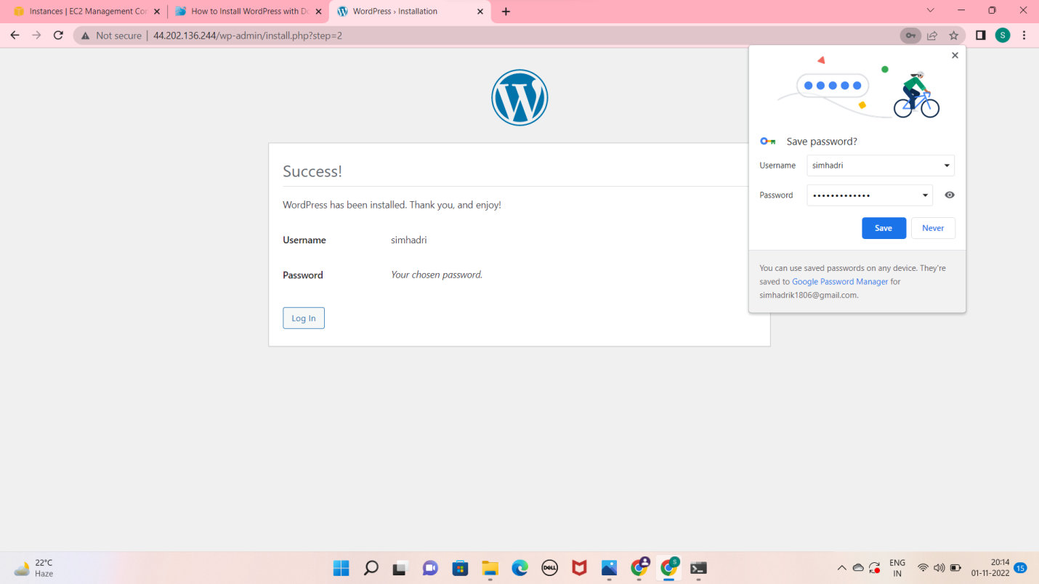

* This is the wordpress welcome page

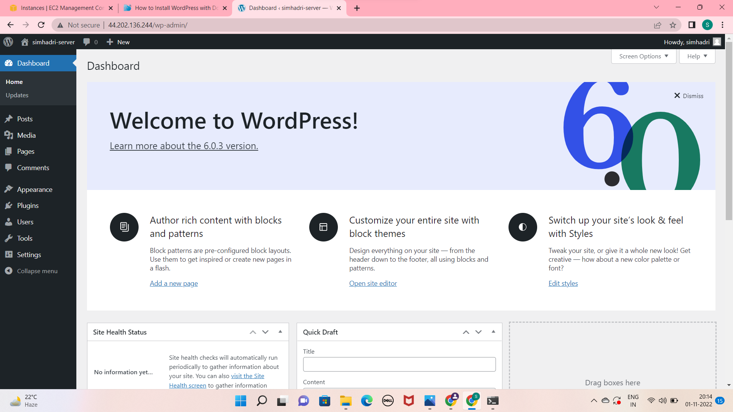

This is the frontend page

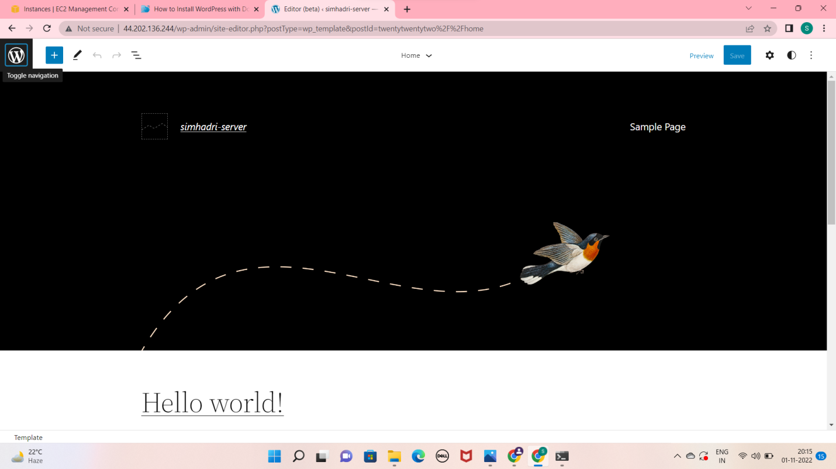

* Push the docker-compose.yaml file into git hub
* Make a folder

Sudo mkdir <name>

* Initialize the folder by using

Sudo git init <folder name>

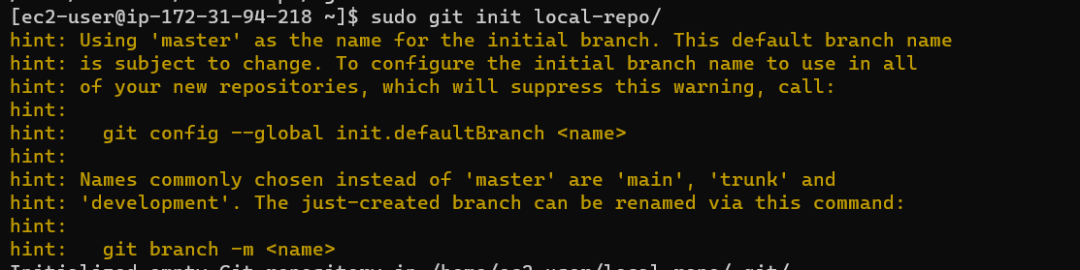

* Create remote repo with same name as local repo with out add readme. file
* In terminal, Change name of git branch from master branch to main branch by using command

git branch –M main

* Give connection to remote repo to local repo

git remote add origin <URL of your remote repo>

* push your file local branch to remote repo

git push –u origin main

* It will ask user name and password

check it in github

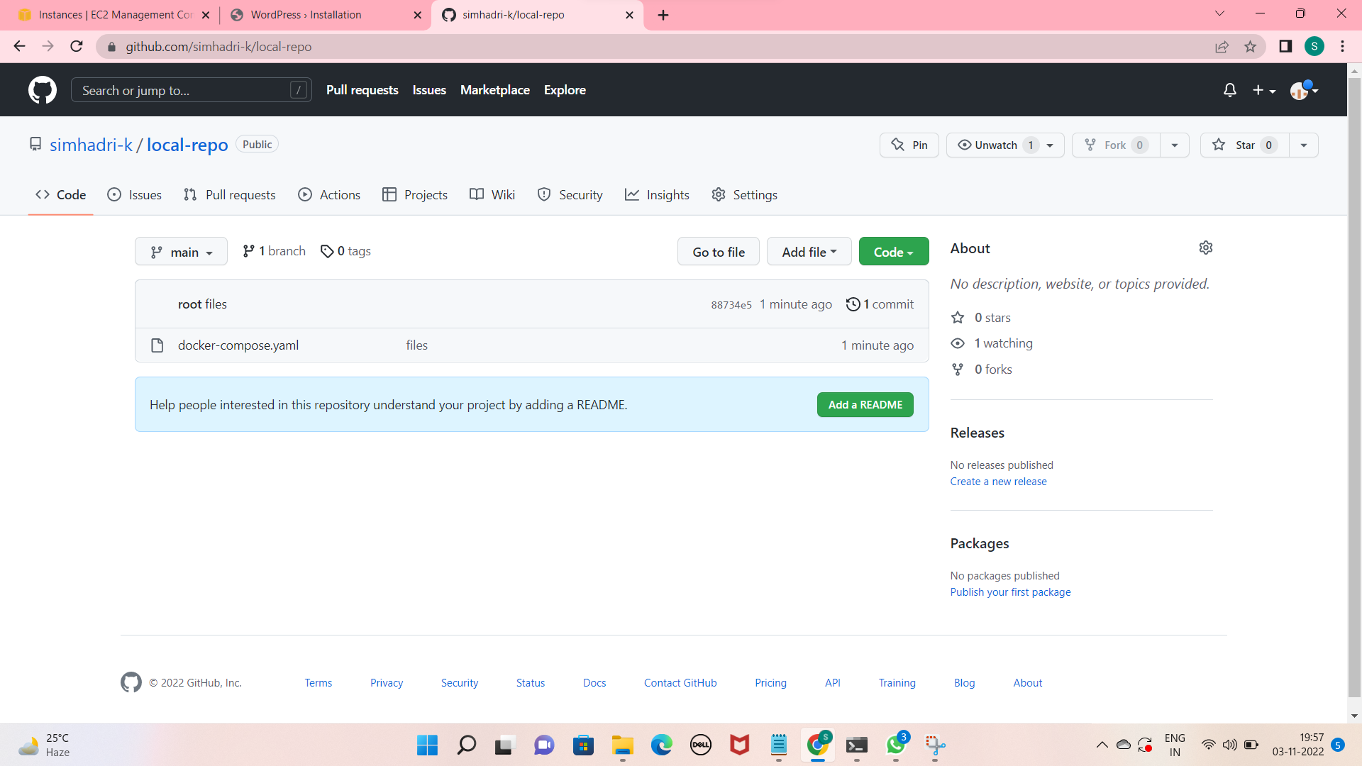

. DEPLOYING WORDPRESS WEB APLLICATION USING JENKINS IN AMAZON WEB SERVICES

* Launch EC2 instance with Amazon Linux 2 AMI and required security group for JENKINS
* Connect SSH client into terminal
* Update the system
* Install Git in instance using

Sudo yum –y install git



Install the java 11 version for the JENKINS

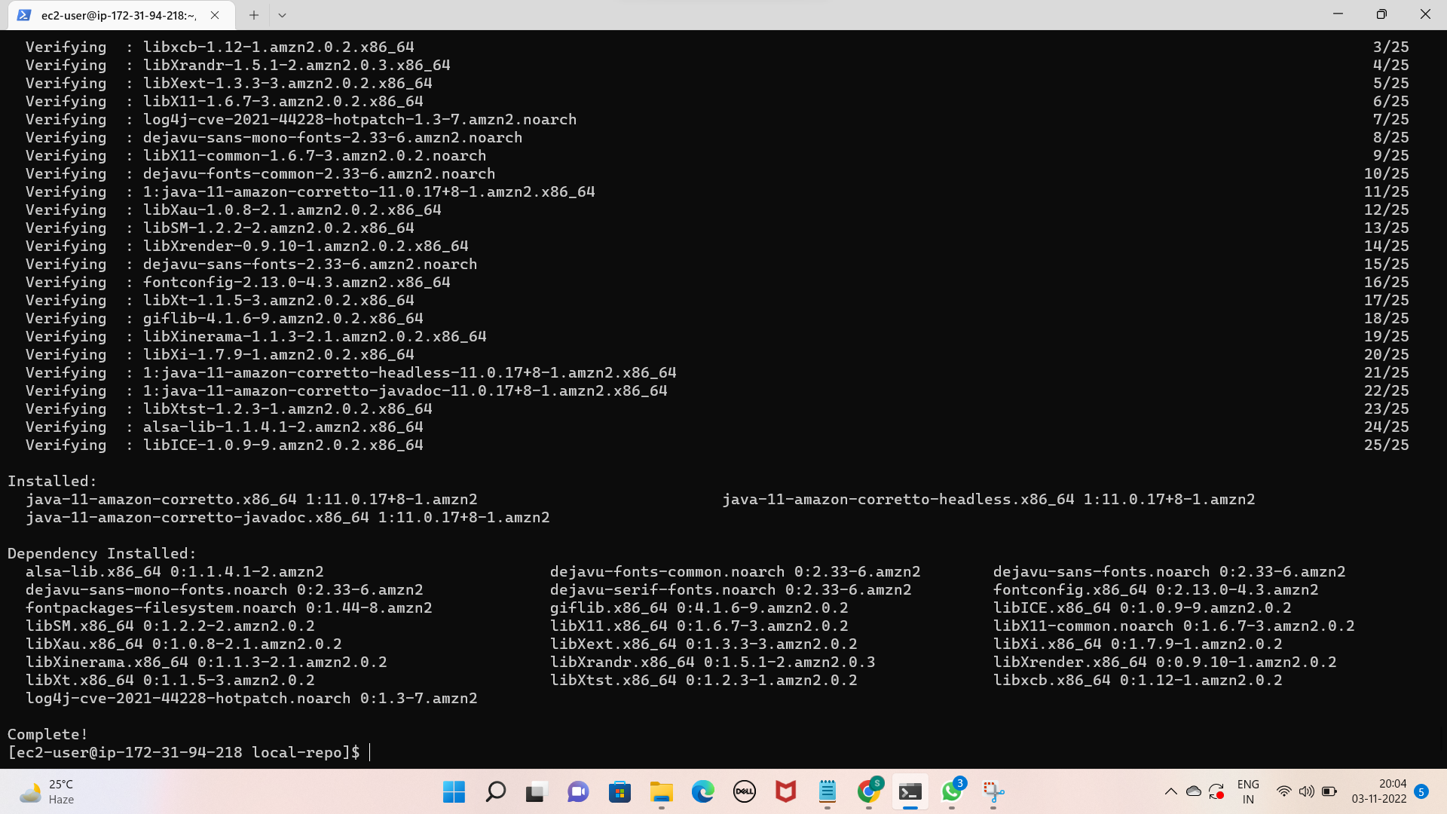

Install Jenkins by using below command

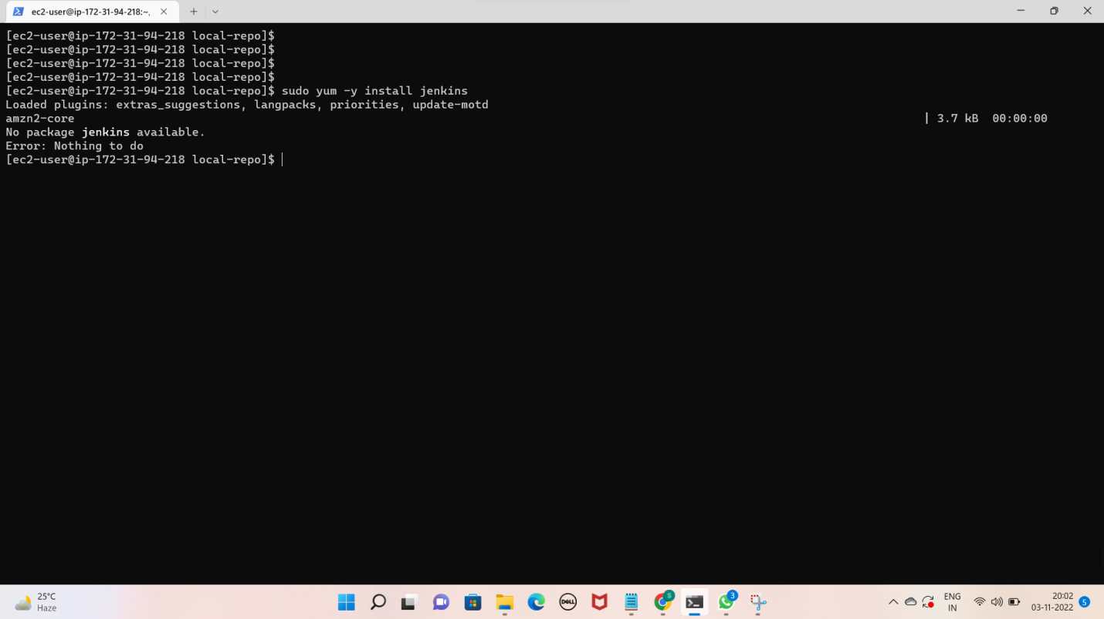

Start the Jenkins service and enable it

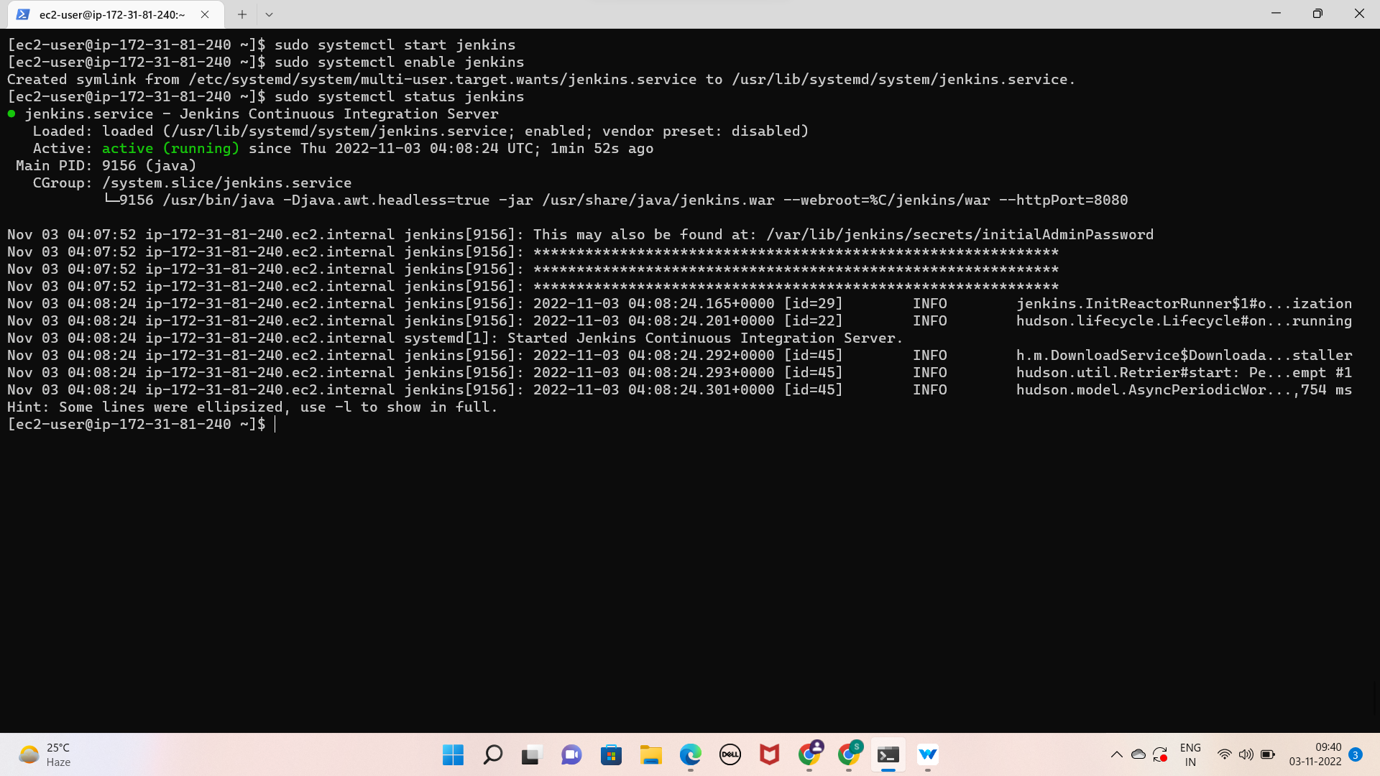

Select installed plugins

Create a new job

In job, clone the code of docker-compose.yml from git hub

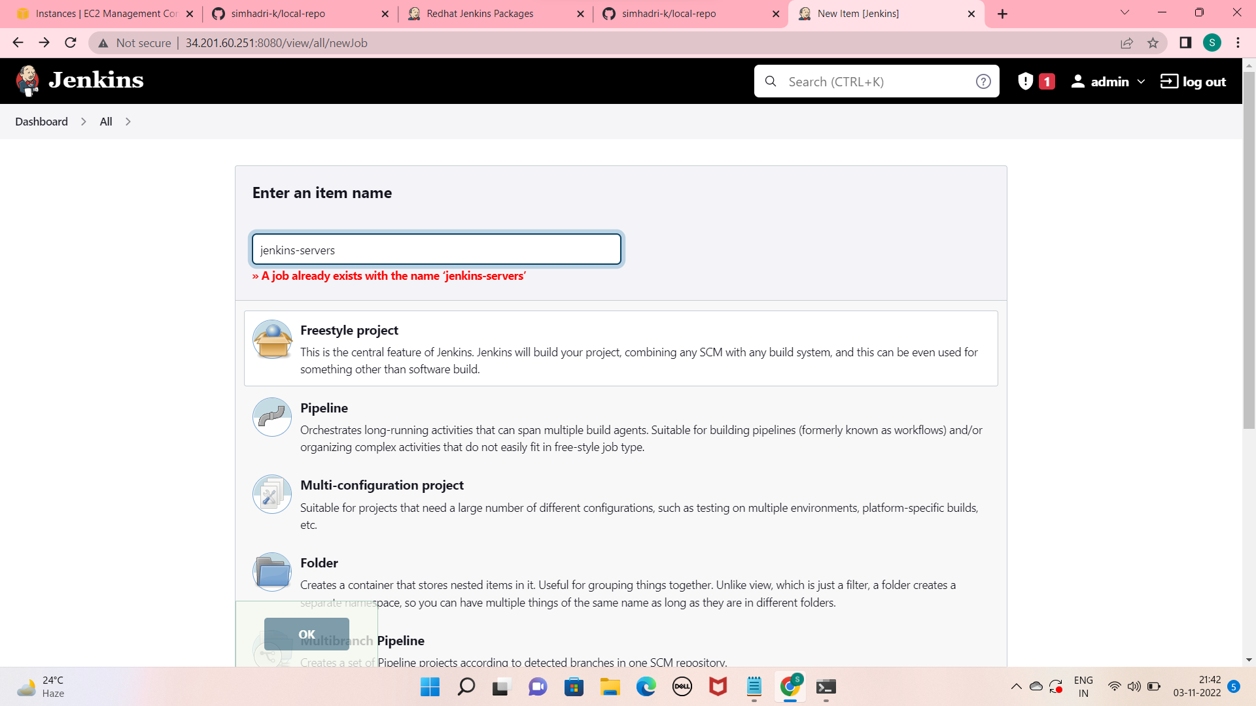

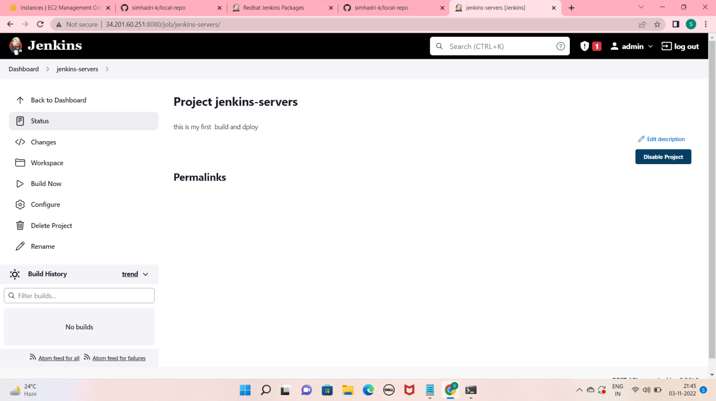

Then , create another job select copy from previous job

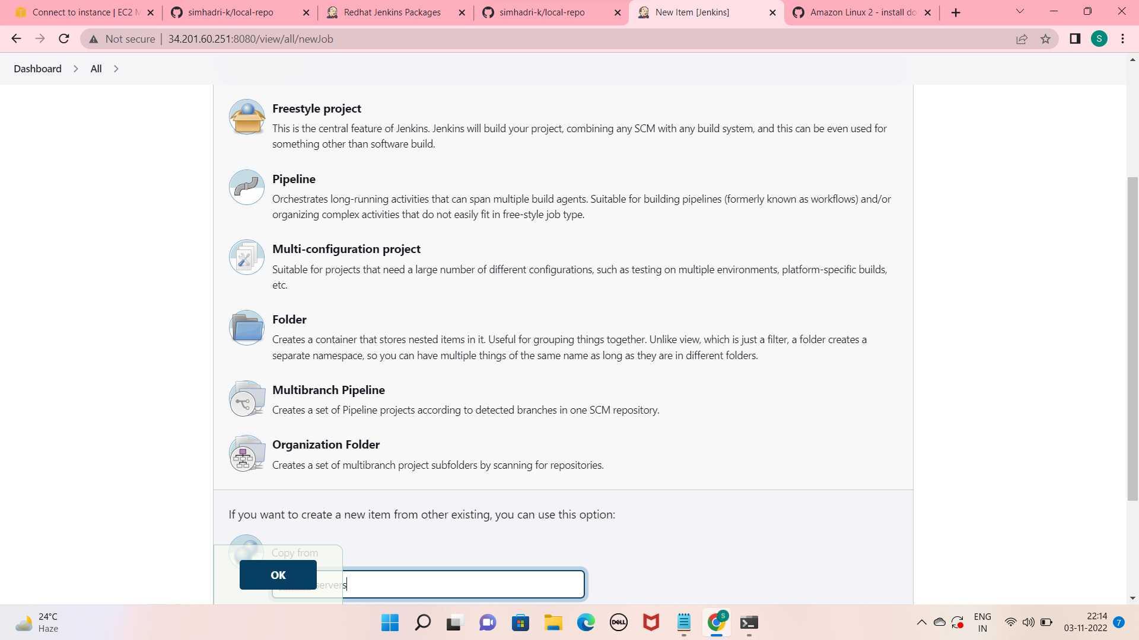

In build section select Execute shell

In Excute shell give command for pulling the images from docker hub

Sudo docker-compose up –d

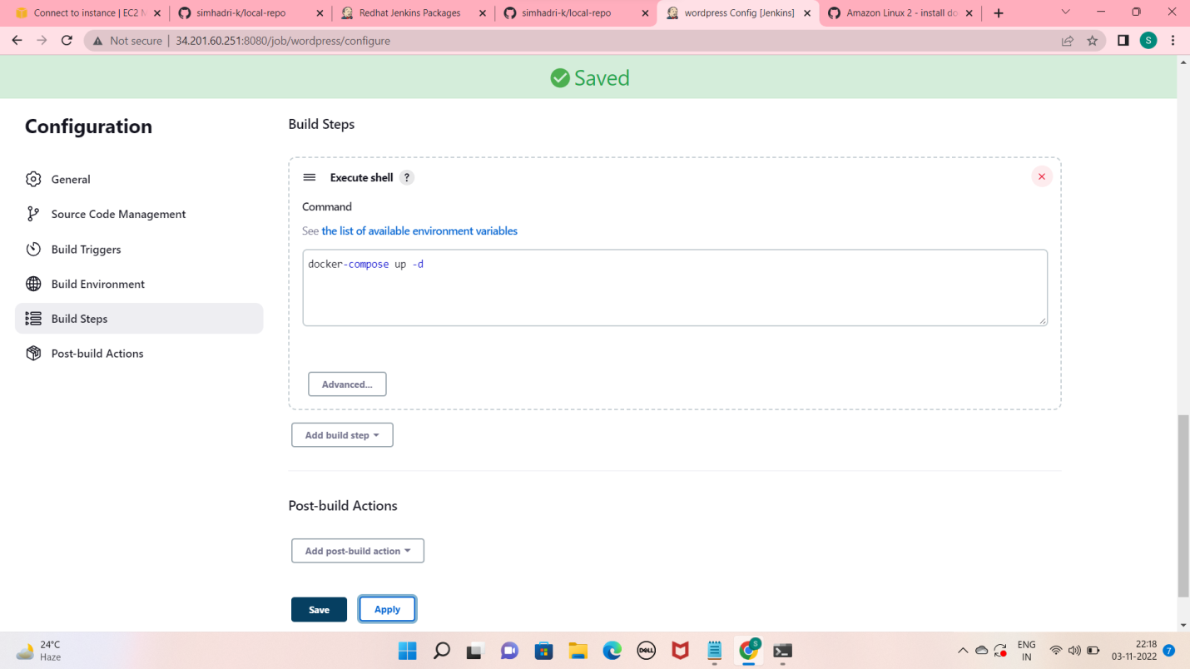

Save it and build now

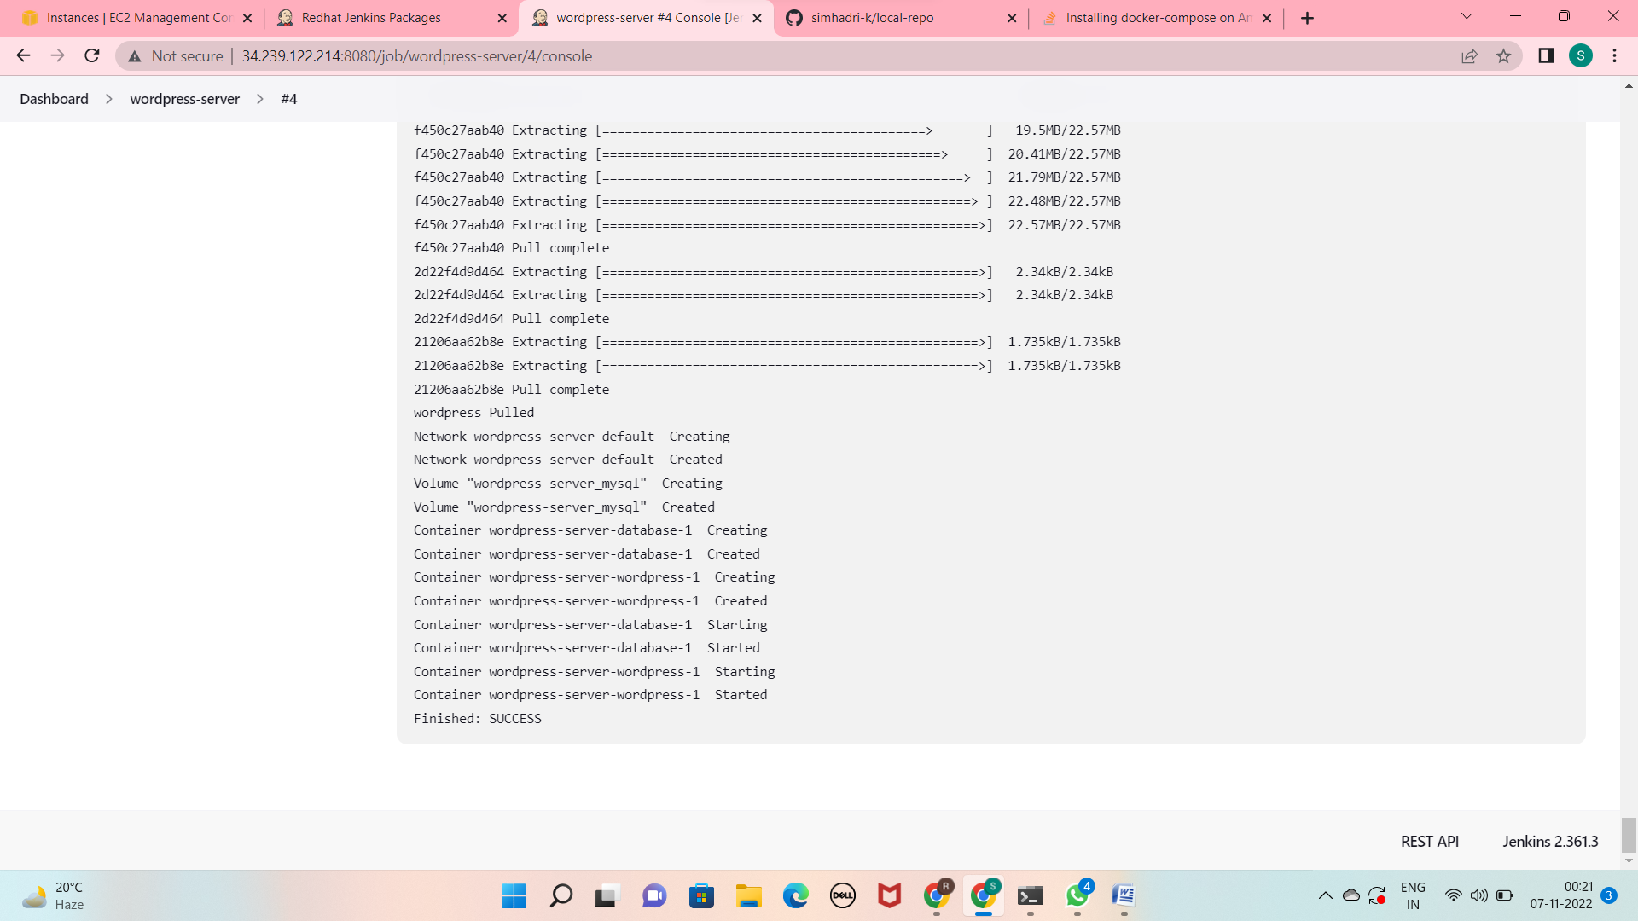

See the wordpress

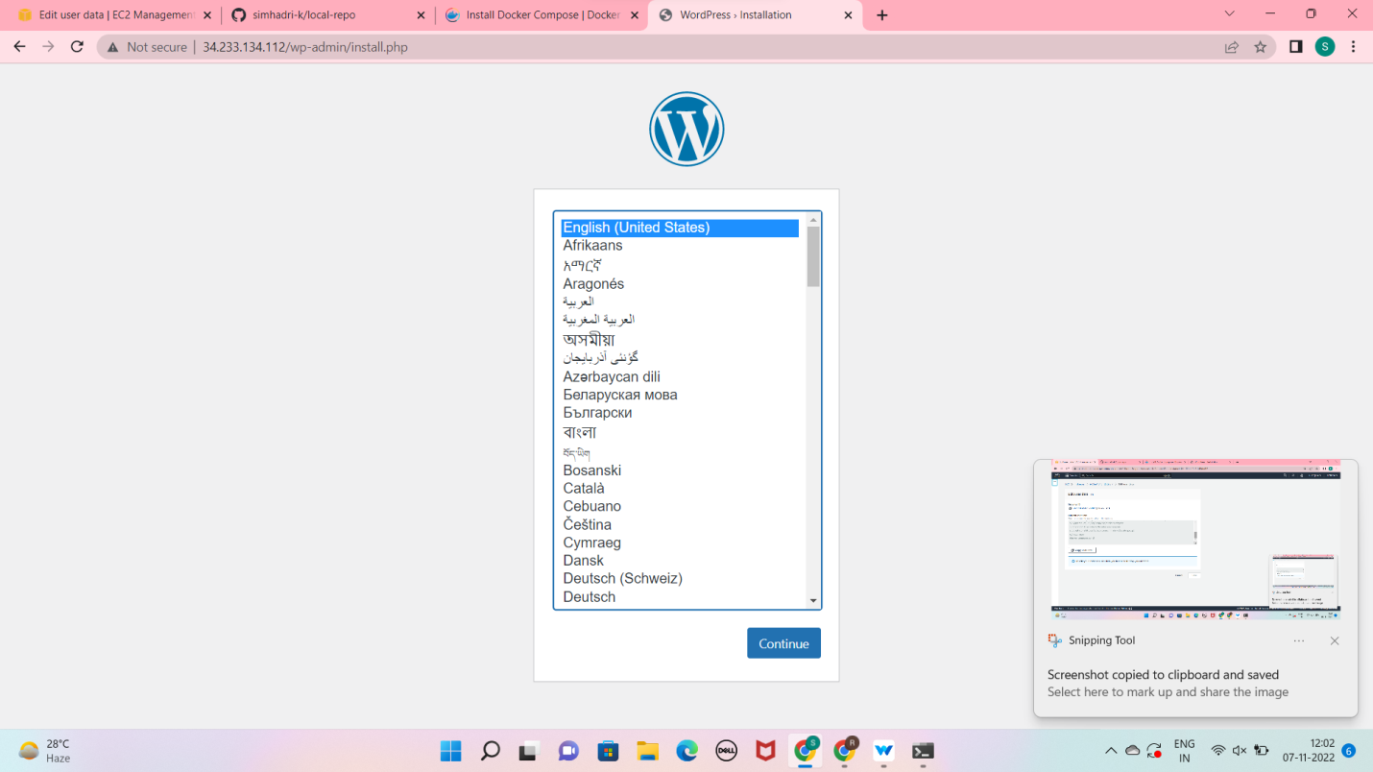

MODULE :5. DEPLOYING WORDPRESS WEB APLLICATION USING SHELL SCRIPTING IN AMAZON WEB SERVICES

Creating and Launching an Amazon Linux EC2 instance

Choose ami

Choose Instance type and Choose key pair

Networking setting (select VPC and Subnets) and Select Security Group

Add storage and select no. of instance (if required)

# Go to advance details and write shell script in user data

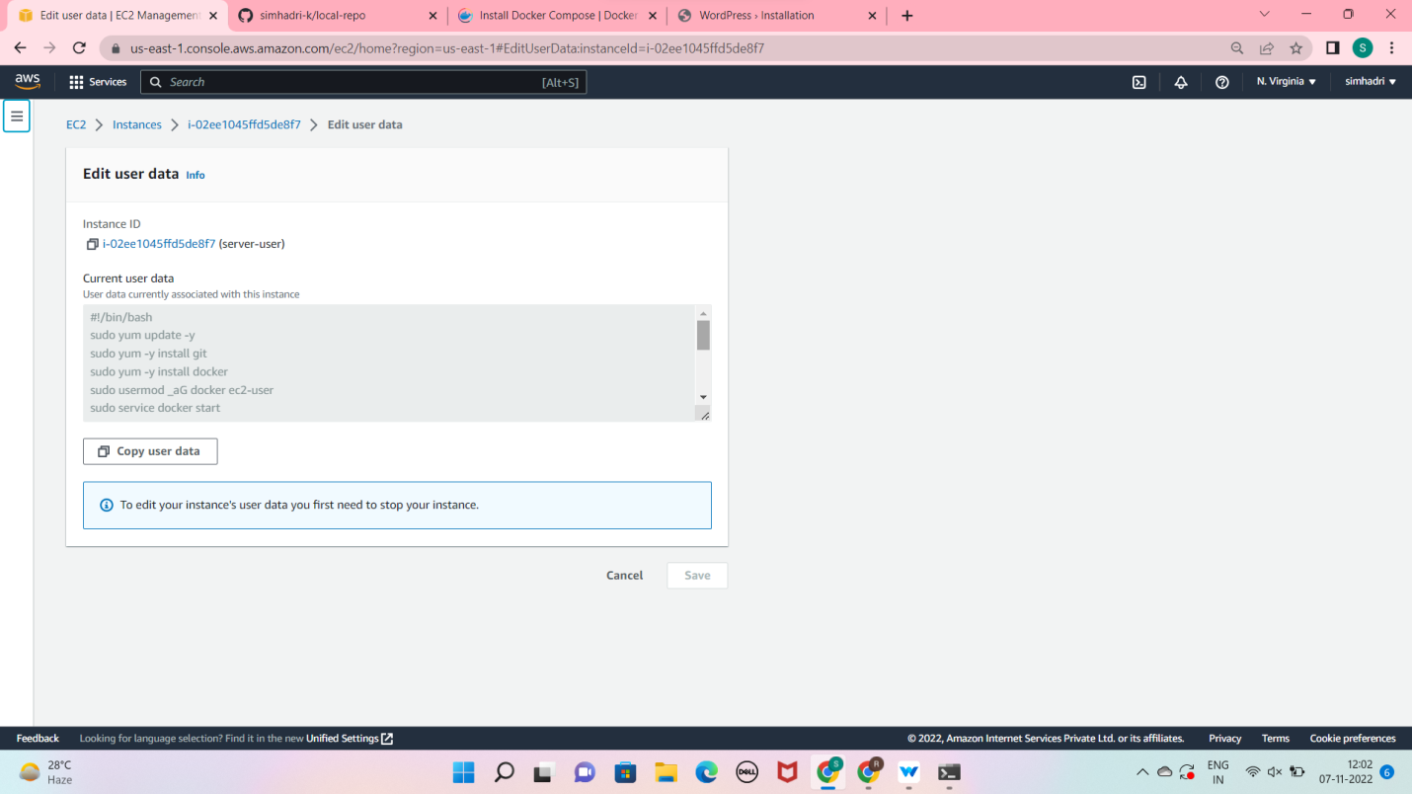

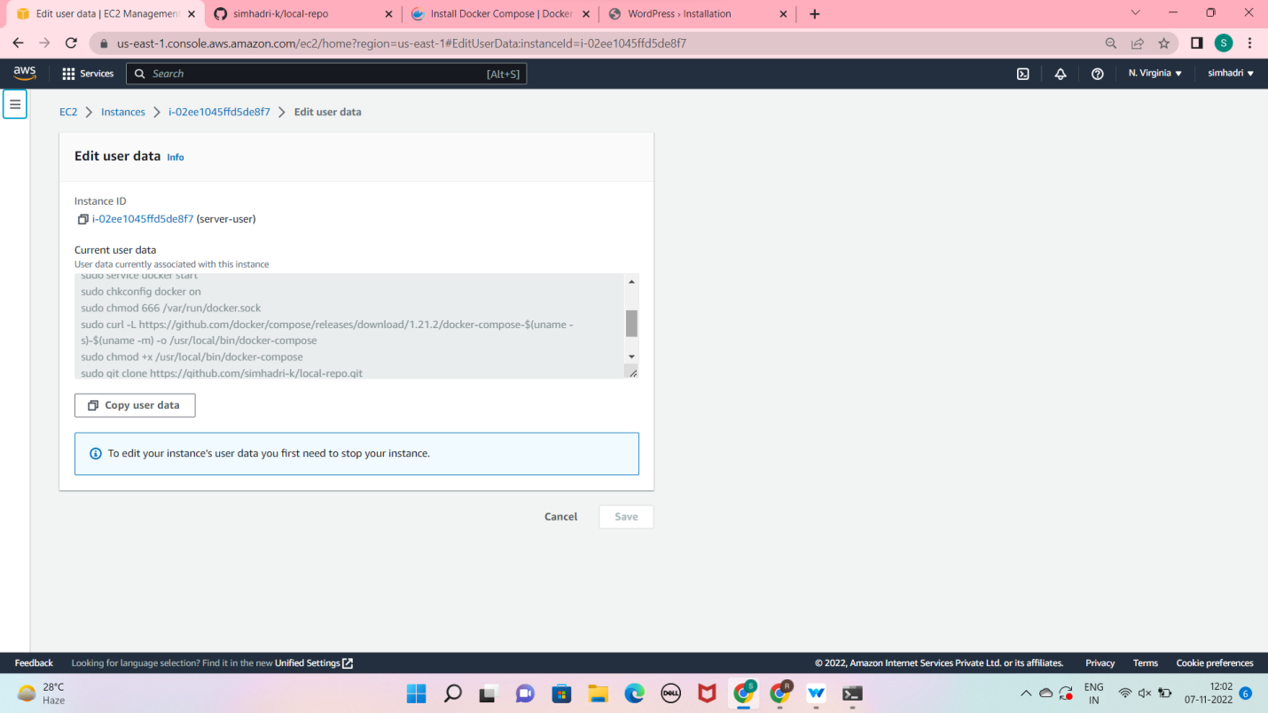

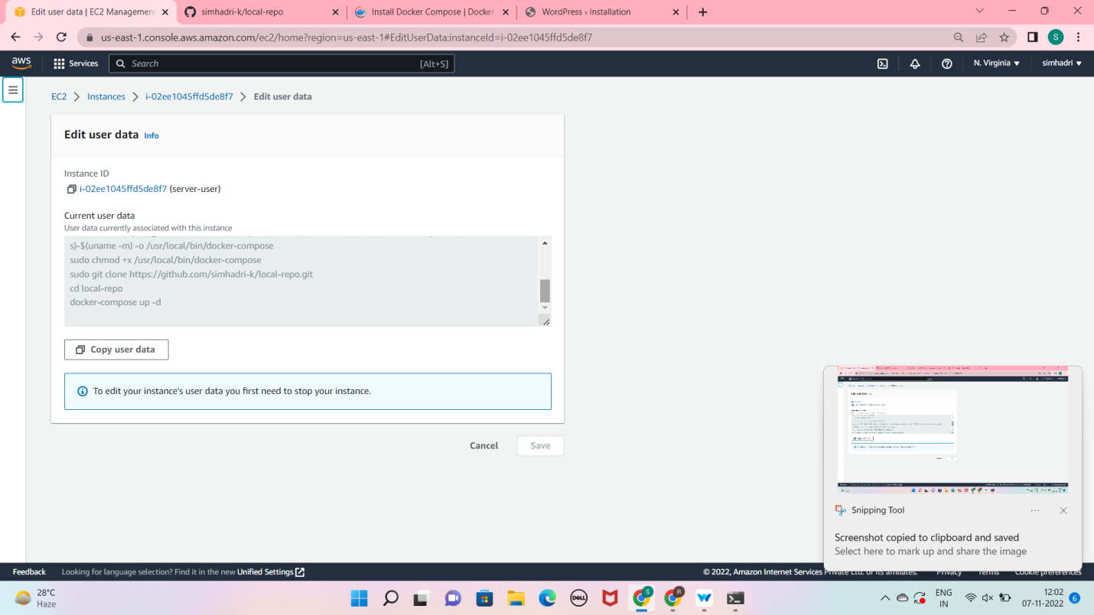

Launch the instance and browse it

And see the wordpress

